Install 3 rhel_10 VMs and install ansible in one machine make it control node another two make 2 remote node
Ping both remote node machine from control node

Step 1. Create a Control Node VM
Step 2. Create a Remote Node1 VM
Step 3. Create a RemoteNode2 VM
Step 4. Register all VMs to Redhat
Username
Password

Step 5. Install Ansible using ansible-core

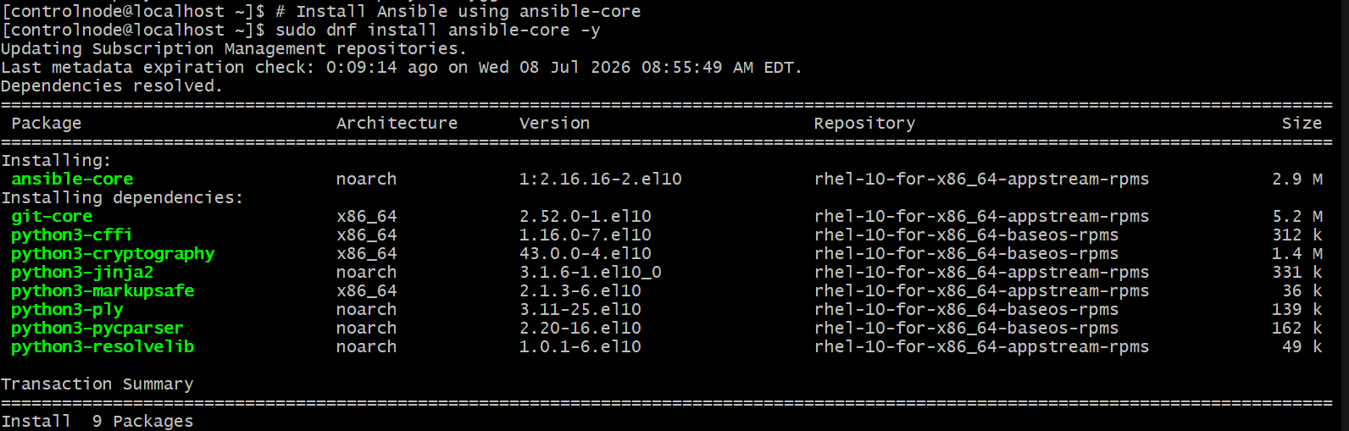

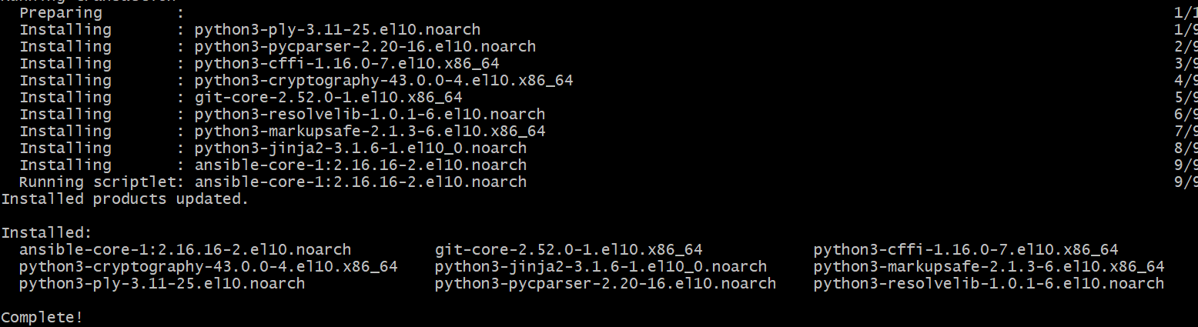

Step 6. Verify Ansible Version

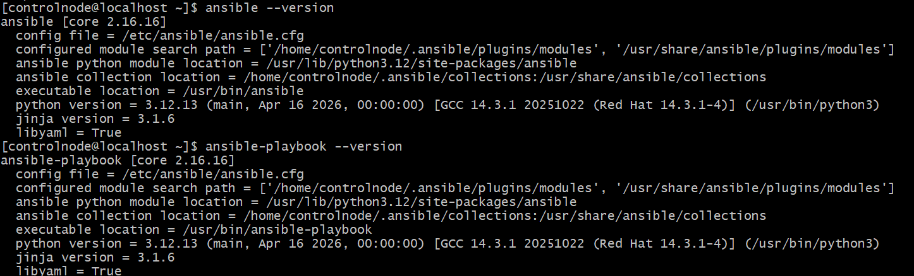

Step 7. Ping remote node 1

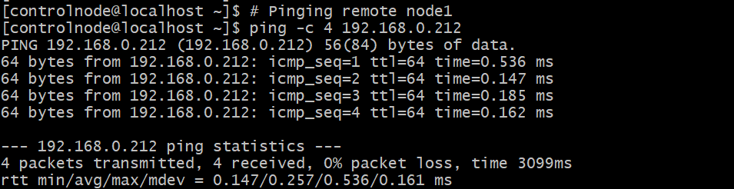

Step 8. Ping remote node 2

